Siddharth Rane

10/1/19

Course: Physics 209

Section: ST5

Lab #2

In this experiment we look at how different indices of refraction affect the distance at which light is projected at.

Procedure:

In this lab we are given several materials. We are given a light source, a track, 2 lens holders with two types of lens, a screen, scissors and an index card. We first begin with the warmup exercise and measure the distance from the source to the lens and the lens to the screen. Then we find the magnification by 1.5 and measure the distance again. Now we find the value of n to see if the material of the two converging lenses are the same. We find p (object distance) and i (focal length) for both lenses. Given the thin lens equation we use that to find the value of f (focal point). Using the lensmaker’s equation we find can then find the index of refraction.

In experiment 2, we placed both lens on the track at a certain distance away from the light source and an inverted image was projected on the screen. We measured the height of the image and the object to determine the magnification of the telescope.

Questions and Data:

Experiment 2

1. Your report should include a description of the experiment you devised to determine the two indices of refraction. You should discuss how confident you are in the measurement, and what basis you have for saying they are the same or different.

*Thinner Lens*

i = 61.4 - 6.4 = 55cm

p= 94.3 - 61.4 = 32.9cm

+ =

= (n-1)

n = 2.99

*Thicker Lens*

i = 73.2 - 52.9 = 20.3cm

p = 94.3 – 73.2 = 21.1cm

+ =

= (n-1)

n = 1.2

2. Find a table of n values on the internet and see if you can determine the exact type of material.

The two lenses are made close to the material of Arsenic Trisulfide glass since the range for that material is 2.086-2.097 and our index of refraction is 2.095.

3. Make sure to include a ray diagram showing how you produced the images.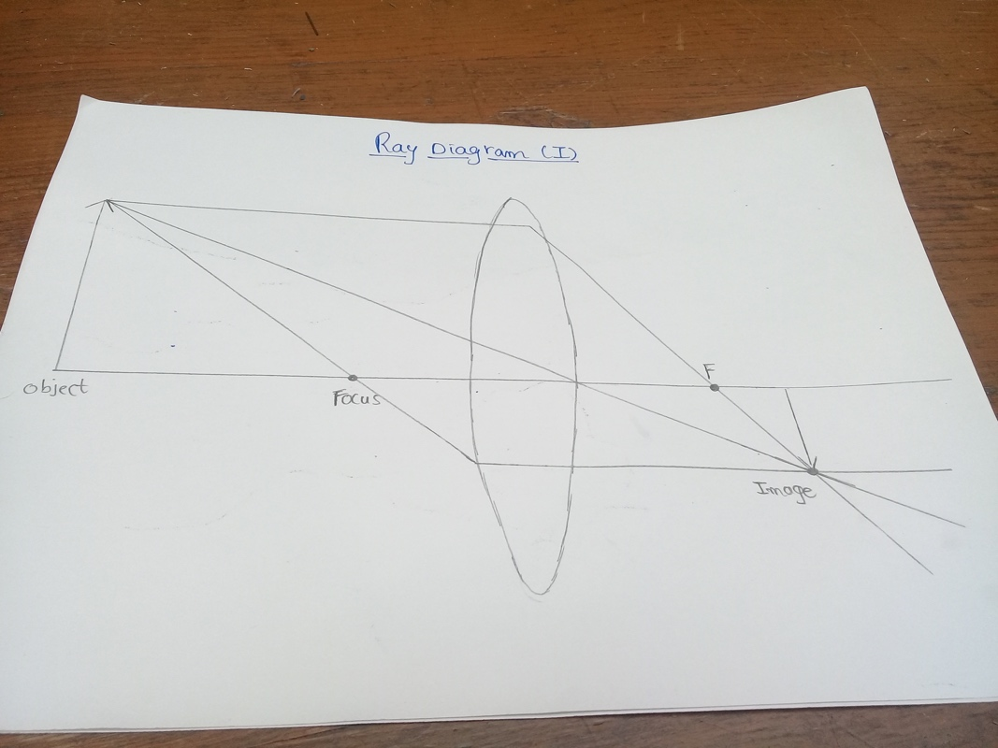

Experiment 2

1. Calculate the magnification of your telescope.
2. Draw a ray diagram of the telescope.

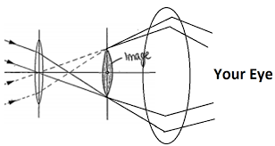

1. Record images like the globe image above to check the magnification values that you obtain analytically.

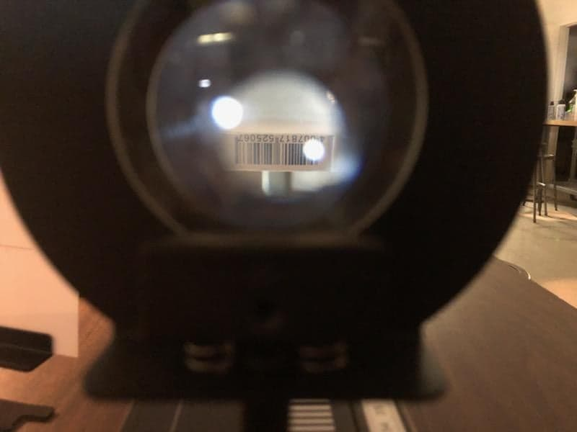 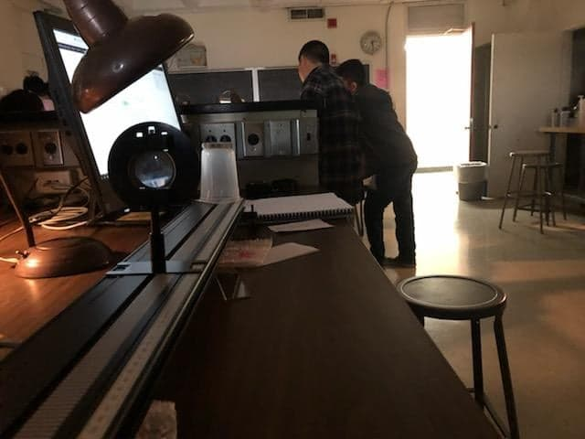

Conclusion:

We concluded in the first experiment that the material of the two lenses are the same because the average of the two gave an index value close to the value of Arsenic Trisulfide glass. In the second experiment, the two lenses created an inverted image but also showed a large image as if it was closer. Essentially, we create a makeshift telescope where we saw the image much closer. However, due to the curvature of the glass, the image was closer but also inverted. One source of inaccuracy was measuring the object and image distance. Another human error is determining the image and object height as the pictures could have been taken at different spots. If the camera’s position changed, that would also alter the distance between the object and the image.